Networking Community

X-ENE's Networking community of current or former Enron employees who are looking for employment or have information regarding employment opportunities

NOTE: you must do this from your home computer. It is a restricted site from within Enron’s fire walls.

1
2
Go to http://communities.msn.com/XENEs
Type in your E-Mail Address and Password
Click the SIGN IN button
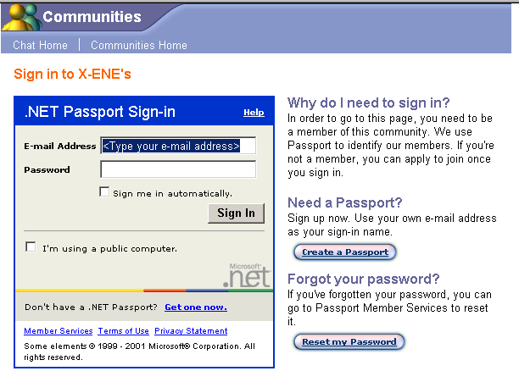

The following screen will appear
4
3
Type the appropriate information in the fields
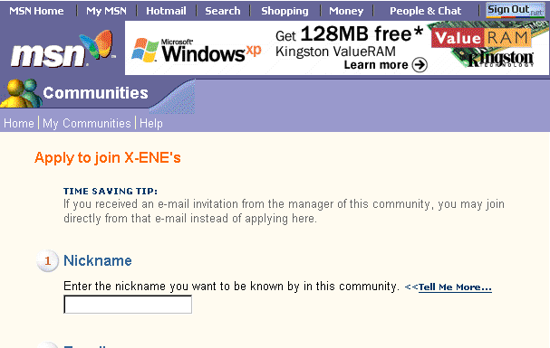

The screen below will appear
Click the APPLY TO JOIN button

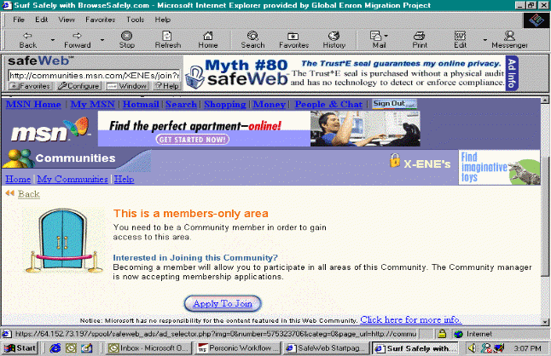

Once you have finished typing in the fields Click the JOIN NOW button
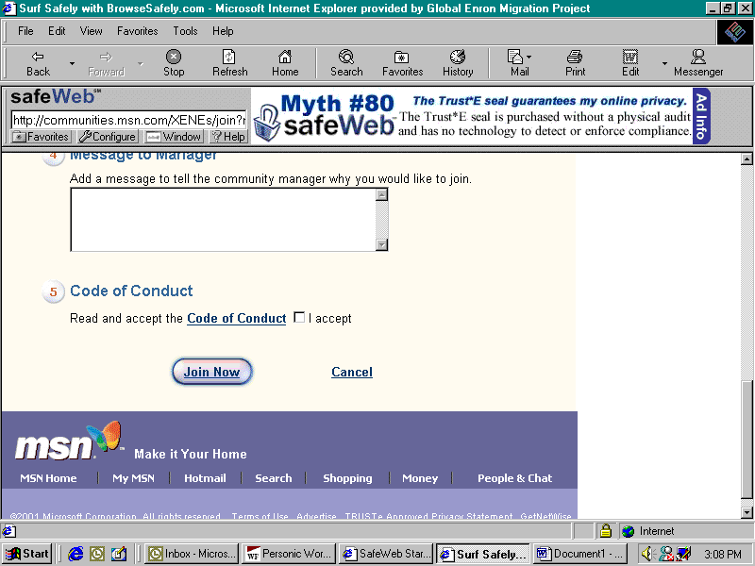

A message will then be sent to the Community Manager. Once you are approved you will receive an email.

